

**FLAIR HAIR AND BEAUTY PARLOUR**

**CAROLINE WANGARI C027-01-0824/2020**

**SHAMIM CONCEPTOR C027-01-0835/2020**

**TABITHA NYABISI C027-01-0832/2020**

**LUCINA KEMUNTO C027 - 01-0827/2020**

A project submitted to the department of Information Technology in the School of Computer Science and Information Technology in partial fulfilment of the requirements for the award of the degree of Bachelor of Business in Information Technology at Dedan Kimathi University of Technology 2022.

**SUPERVISOR**

John Ngechu

Everlyne Ngatho

13/6/2022

# **DECLARATION**

We hereby declare that the work entitled “FLAIR HAIR AND BEAUTY PALOUR” submitted to the Dedan Kimathi University under the department of Computer Science & IT is a record of our original work done by the four of us. The results embodied in this thesis is our original work and has not been submitted in any university;

**NAME SIGNATURE DATE**

CAROLINE WANGARI ………………… ……………

SHAMIM CONCEPTOR ………………… ……………

TABITHA NYABISI ………………… ……………

LUCINA KEMUNTO ………………… ……………

The proposal has been submitted to the university supervisor

**NAME SIGNATURE DATE**

John Nge`chu ………………… …………….

Everlyne Ngatho ………………… …………….

**DEDICATION**

We dedicate this project to our customers who have been a great inspiration to us in this project. we would also like to sincerely appreciate our tutors and supervisors who have given us the appropriate guidance we needed to cultivate our skills and develop a project that would be helpful to the parlour.

# **ACKNOWLEGEMENT**

We would like to thank God for the good health that He has given us throughout the period that we had to do our project till it has come to an end. We would also like to thank our supervisors especially Mr Ng`echu John and Miss Evelyne Ngatho who offered guidance and assistance through the 8 weeks of our project. Without them the project wouldn`t be a success.

**TABLE OF CONTENTS**

**DECLARATION** 2

**ACKNOWLEGEMENT** 4

**TABLE OF FIGURES** 9

**CHAPTER 1**: **INTRODUCTION** 10

**1.1BACKGROUND** 10

**1.2 PROBLEM STATEMENT** 11

**1.3 OBJECTIVE** 12

1.3.1 General Objective 12

1.3.2 Specific Objective 12

**1.4 RESEARCH QUESTIONS** 12

**1.5 JUSTIFICATION** 12

**1.6 SCOPE** 13

**CHAPTER 2: LITRATURE REVIEW** 14

**2.1 INTRODUCTION** 14

**2.2 CASE STUDY** 14

2.2.1 Case study- Toni & Guy 14

2.2.2 Case Study 2 TOSCA 15

**2.2.3 CASE STUDY 3** 16

2.2.3.1 Divas Beauty Spot 16

**2.2.3.2 ARISTOCUTS SALON SPA** 16

**2.3 SWOT ANALYSIS** 17

**2.4 RESEARCH GAP** 17

**2.5 PROPOSED METHODOLOGY** 18

**CHAPTER 3: METHODOLOGY** 19

**3.1 INTRODUCTION** 19

**3.2 RESEARCH DESIGN** 19

**3.2.1 Requirement planning** 20

**3.2.2 User design** 20

**3.2.3 Construction** 20

3.2.4 Testing and implementation 20

**3.3 LOCATION OF THE STUDY** 20

**3.4 TARGET POPULATION** 21

**3.5 SAMPLE AND SAMPLING PROCEDURE** 21

**3.6 DATA COLLECTION METHODS** 21

**3.6.1 Observation** 21

3.6.2 Questionnaire 21

3.6.2.1 Lack of experts 22

3.6.2.2Time Management 23

**3.6.3 Interviews** 26

**3.7 METHOD VALIDATION** 26

3.8.DATA ANALYSIS TECHNIQUES 27

**4.1 INTRODUCTION** 28

**4.2 REQIUREMENT ANALYSIS** 28

**4.2.1 Functional requirements** 28

**4.2.2 Non – functional requirements** 29

4.3 SYSTEM ANALYSIS 29

4.3.1 USE CASE DIAGRAM 29

**4.3.2 DATA FLOW DIAGRAM** 30

**4.4 SYSTEM DESIGN** 31

4.4.1 ACTIVITY DIAGRAM 31

**4.4.2 SEQUENCE DIAGRAM** 32

a). Client Sequence Diagram 32

b). Administrator sequence diagram 33

4.4.3 CLASS DIAGRAM 34

4.4.4 ADMINISTRATOR INTERFACE 35

4.4.4 APPOINTMENT INTERFACE 36

4.4.5 DEPLOYMENT DIAGRAM 37

**CHAPTER 5: TESTING AND IMPLEMANTATION** 38

**5.1 INTRODUCTION** 38

**5.3 METHODS USED IN TESTING** 38

**5.3.1 Test data plans** 39

5.3.1.1 Login authentication: 40

5.3.1.2 Additional of services. 41

**5.4 IMPLEMENTATION** 41

5.4.1 Definition 41

5.4.2 File conversion strategy 41

**5.4.3 Implementation method** 42

**5.4.4 Acquisition of hardware and software** 42

**5.4.5 Training the user** 42

**CHAPTER 6: SYSTEM DOCUMENTATION** 43

**6.1 INTRODUCTION** 43

**6.2 TYPES OF SOFTWARE DOCUMENTATION** 43

a). Internal software documentation. 43

b). External software documentation 44

6.3 TECHNICAL DOCUMENTATION 45

*REFERENCES* 48

APPENDIX 49

# **TABLE OF FIGURES**

Figure 1 Rapid Application Development 19

Figure 2.Lack of experts. 22

Figure 3.Time Management 23

Figure 4.People who had to wait to be attended to 24

Figure 5.Population finding online booking efficient 24

Figure 6. The questions asked in the survey 25

Figure 7. Use case 29

Figure 8. Data Flow Diagram. 30

Figure 9.Activity diagram 31

Figure 10.A Client sequence diagram 32

Figure 11. Administrator sequence diagram 33

Figure 12.Class diagram 34

Figure 13.Administrator interface 35

Figure 14. A booking interface 36

Figure 15.Deployment diagram 37

Figure 16. Login authentication 40

Figure 17.A picture of how an admin can add or remove services 41

Figure 18. Picture notifying that the booking was successful. 45

Figure 19. A picture showing that admin interface woks correctly. 46

Figure 20. How to start xampp 47

Figure 21 Google forms1 52

Figure 22 Google forms 2 53

Figure 23 Google forms 3 54

# **CHAPTER 1**: **INTRODUCTION**

## **1.1BACKGROUND**

Most of us pay a visit to a beautician to receive beauty services. This, is so as to make us feel and look handsome/beautiful. Some may argue that beauty lies deep but John Kerr said” I`m tired of all the nonsense about beauty being skin - deep. That’s deep enough. What do you want, an adorable pancreas?” Word around the street says that `Let your looks do the talking’

However, getting your looks done, is not an excuse to spend the whole day at a beauty studio, waiting to be attended to or to receive the services desired. For the longest time now, we have witnessed chaos at the beauty parlours. Chaos resulting from arguments between clients and the beauticians, beauticians and their managers on who should attend to a client. This makes the place not to have some serenity. A place where most of the people go to have some peace of mind, relax and also for some tranquillity.

That was why booking of appointments was introduced at beauty organisations. This was mostly done manually This introduction of such a system turned out to be tiresome and straining as it involved a lot of paper work. There are also several times where there was an imbalance in the booking of the appointments. Days that had more appointments booked in a day, days that appointments were colliding and days that had no appointments booked. Issues like this just ended up not solving the previous challenges experienced by these beauty organisations.

This was a problem that we noticed is experienced in most of the beauty industry and creating a standard based system will help to solve some the existing issues in many ways. For example, Flair Hair and Beauty is one of the beauty organisations that experiences such problems. By creating a system that will allow the client to view the available day and hour for booking an xiappointment, choose the preferred service that they want, view the total price that they will be required to pay for the service , allow them to book or cancel their bookings on time, will be very convenient to the client and also for the beauty organisation

It will also be convenient to the beauty organisation as the system will require the client to pay a small amount of deposit so as to avoid having issues like, client booking for an appointment and not showing up. In the event that the client doesn’t show up, the deposit will be non-refundable. It will just be rescheduled. The system will also allow the beauty organisation manager to cancel an appointment that seems to have collided with the other and reschedule it by contacting the client.

The system will be implemented using the following programming languages; JavaScript, CSS, HTML, and Database.

## **1.2 PROBLEM STATEMENT**

Manually booking of appointments at hair and beauty parlour organisation is inconvenient to a client and workers. This is because both the client and workers’ time is limited.

The client may require some special services that may not be available in the service provider work place, a client may also be requiring a certain service that no one in the work place can offer, a customer books for a service but the service provider is already busy by the time he/she arrives, the workplace may be already full and all the services providers are occupied making the others to wait and lack of customers may result to closing making the customers go home or look for another place.

## **1.3 OBJECTIVE**

### 1.3.1 General Objective

To create a standard based website that helps to allocate the clients to a specific service beautician at a specific time and vice versa.

### 1.3.2 Specific Objective

The website should help us to achieve the following objectives;

(i) Enables customers to choose services.

(ii)Enable customers to easily book appointment.

## **1.4 RESEARCH QUESTIONS**

(i) Can one choose the services?

(ii) Can you book an appointment easily?

## **1.5 JUSTIFICATION**

A beauty organisation is normally occupied and busy. The services provided there require different amount of time and different resources. When there is manual booking of the beauty appointments, it may occur that a certain service, requires more time than the other. This will be inconvenient to a certain client who came late and requires a lesser time for a certain style or service and has to wait for the person who requires more since, the customers are served by the first come first served method. It is because of such a problem that there is need for an online booking system, that will aim at being convenient to its customers hence a good customer service.

## **1.6 SCOPE**

Beauty and hair organisation website is used in kenya. Hence it ’s main purpose is to make both the clients and service providers to save time and make their work easy. The website is not required to go out of the scope, it revolves around it.

# **CHAPTER 2: LITRATURE REVIEW**

## **2.1 INTRODUCTION**

In order to establish and develop a standard beauty and hair service booking website that favour both the customer and workers, we need to review the following case studies:

## **2.2 CASE STUDY**

### 2.2.1 Case study- Toni & Guy

This website is luxurious, yet approachable. The landing page is simple, concise and contains all the necessary information. Content is spaced appropriately so as not to overwhelm the visitor. The homepage is concise and the website contains only a few extra pages.

Call-to-action buttons are effective tools, which appear throughout the website, encouraging visitors to take the step from viewer to client. The website also allows the clients to share the information with others which helps them to get more clients. The website also provides the location of TONI&GUY by uploading a map. The call-to-action buttons allows the clients or visitors to schedule an appointment.

The page of the site explain the services, prices, location and more. It sells products, books appointments, includes a magazine and career information.

The website does not display the time the stylist or service provider is available which may cause congestion if many clients book at a particular time. This results to the client waiting to be attended to which causes time wastage.

TONI&GUY also does not provide transport for the client which may be costly for the clients if the organisation is far.

Our website rectifies all this by; including the time the service provider is available, offer transport to and from the organisation and also takes the services to the clients home if the client requests it.

### 2.2.2 Case Study 2 TOSCA

Tosca salon is located in the Western Cape.

They gear to give the clients a home away from home experience where they can relax, revive and renew.

In their websites the services provided are displayed and the products they sell and use. Their email and contacts are also in the website for the clients to communicate with them. The website does not give much information about the organisation.

Our website will provide enough information to the clients. For those who do not know the location of the organisation there will be a map and also transport will be provided. The work hours will also be displayed for all the service providers and the time they are available.

## **2.2.3 CASE STUDY 3**

### 2.2.3.1 Divas Beauty Spot

Divas beauty spot is a full-service men and women hair and beauty parlour and salon. It seeks to provide the best friendly and personalized services through a team of highly skilled and creative professionals in a clean relaxing environment.

The website provides a map to give direction to a new client. There is also an email and the contact information that are used in case of any queries. The website also displays the timeline i.e the working hours and the days they are open including the weekends.

The organisation buy, package and deliver gifts to your loved ones on those special days. They deliver gift items within Nairobi CBD and can also arrange to deliver by courier to any other destination in the country.

Our website will display at what time a certain service provider is available. The organisation will also provide transport of clients to and from the organisation.

### **2.2.3.2 ARISTOCUTS SALON SPA**

It is an organisation that provides services to both men and women at all time. The website provides the location for a new client by providing a map.

There is a platform where the clients can give their feedback and post their complains. It also allows the clients to ask questions. The website also displays the working hours and the days the are open including the weekends.

The organisation has very short hours of performance which may not be effective to the clients. The service provider may offer to go to the client home to attend to the client if the service does not require a lot of requirements.

Our websites will also display the time a certain service provider is available to avoid congestion in the spa.

## **2.3 SWOT ANALYSIS**

The weaknesses we have identified from other research organisations that need some improvements are;

(i)Booking transport services that delivers clients to the organisation. This is a problem encountered by mostly new clients.

(ii)The unavailability of a platform for the clients to file their complains, suggestions and feedback.

(iii)Issues arose over clients wanting to be served with specific resources or services yet they are not available.

## **2.4 RESEARCH GAP**

From most of the researches that we observed, it was very evident they were shy to solve most of the problems in one website. For example, the House of Beauty did not solve the problem that most clients had that is, getting the beauty products and services in one website. Our website looks forward to solve most of the problems that clients complained about on the other sites. These are;

-Solving the problem of congestion at workplaces by letting the customer to know the appropriate time to come or the service provider will be available.

-To solve the problem of time wastage in that the customer does not have to come and wait for the service provider, he/she is informed when the provider is available by manually making calls to their clients.

## **2.5 PROPOSED METHODOLOGY**

The kind of methodology that we opted for in the creating of this website is, Rapid Application Development. We also used the activity diagrams, sequence diagrams, use case diagrams, context level diagrams.

# **CHAPTER 3: METHODOLOGY**

## **3.1 INTRODUCTION**

This section describes the methods that will be used to gather requirements for the system.

## **3.2 RESEARCH DESIGN**

During this project the preferred methodology to be used during the development process will be Rapid Application Development model. Since it has few errors and also has both lower development cost and lower maintenance cost. The Rapid Application Development is split into four phases; requirement planning, user design, construction and testing and implementation.

We used RAD because:

i. It is flexible and adaptive to changes.

ii. It is useful when you have to reduce the overall project risk.

## 

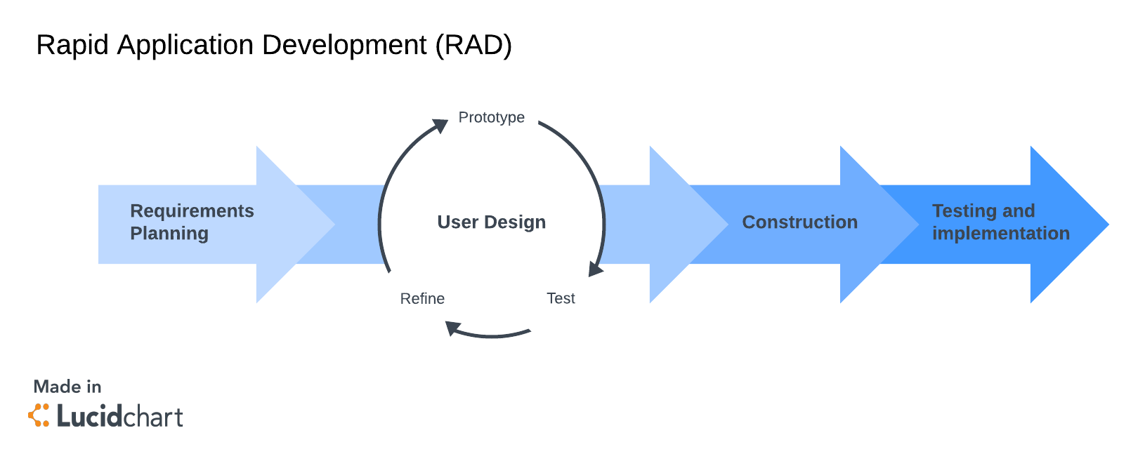

Figure 1 Rapid Application Development

### 

### **3.2.1 Requirement planning**

The website will make it easier for both the clients and service providers to plan their time since they know the person they are allocated to and at what time. The owner also plans on the products to be added to the stock depending on what the clients use often. The owner may also decide to add some products due to the demand.

### **3.2.2 User design**

This web-based project can be accessed by any client that wishes to book an appointment with their stylists. This will be done at the comfort of their homes through a smartphone to access the intended services. The beauty organisation will know when they will be ready for their clients. This will be beneficial to both the clients and the customers as they will be able to know at what time they can offer or receive certain services.

### **3.2.3 Construction**

To implement this system, we shall use HTML, CSS, JavaScript and Database to design the kind of system we would like the customers to interact with. A system that will also be easy for the beauty organisations to work with.

### 3.2.4 Testing and implementation

Here we allow few customers to access the website so that they can test and identify if it has a problem. If there is a problem, we solve it then implement it.

## **3.3 LOCATION OF THE STUDY**

Being in Nyeri town, we visited salons, barbershops and beauty parlours to do our research from clients and stylists.

## **3.4 TARGET POPULATION**

Since it is a global coverage, there was no target group since at a point everyone visits a salon or barbershop to get their hair done.

## **3.5 SAMPLE AND SAMPLING PROCEDURE**

We interviewed the business organisation owners, several service providers and the end customers.

## **3.6 DATA COLLECTION METHODS**

The data collection methods are as follows;

## **3.6.1 Observation**

We observed that most of the beauty parlours, salons and barbershops are mostly congested due to lack of proper planning of time making the customers to wait for them to be attended to.

The shop may lack some of the products making the customer to go and buy in another shop which is time wasting.

Untrustworthiness between the employer and employee; the employee may decide to overcharge the customers and give the employer less money.

## 

## 3.6.2 Questionnaire

We created google forms and shared it. A good number responded to it and we were able to get our feedback in time. The questions featured both open ended and closed questions. The period for responding to the form was three weeks and at least fifty people responded.

### 3.6.2.1 Lack of experts

Figure 2.Lack of experts.

Most of the customers do not enjoy the services offered due to lack of an expert or being given another stylist.

### 3.6.2.2Time Management

Figure 3.Time Management

Appointment scheduling was not easy since maybe all the stylist or service providers were occupied with another customer.

Most customers had to wait for a long time for their service provider to arrive at work or even to finish the previous customer.

Figure 4.People who had to wait to be attended to

People find online booking efficient since it will save a lot of time.

Figure 5.Population finding online booking efficient

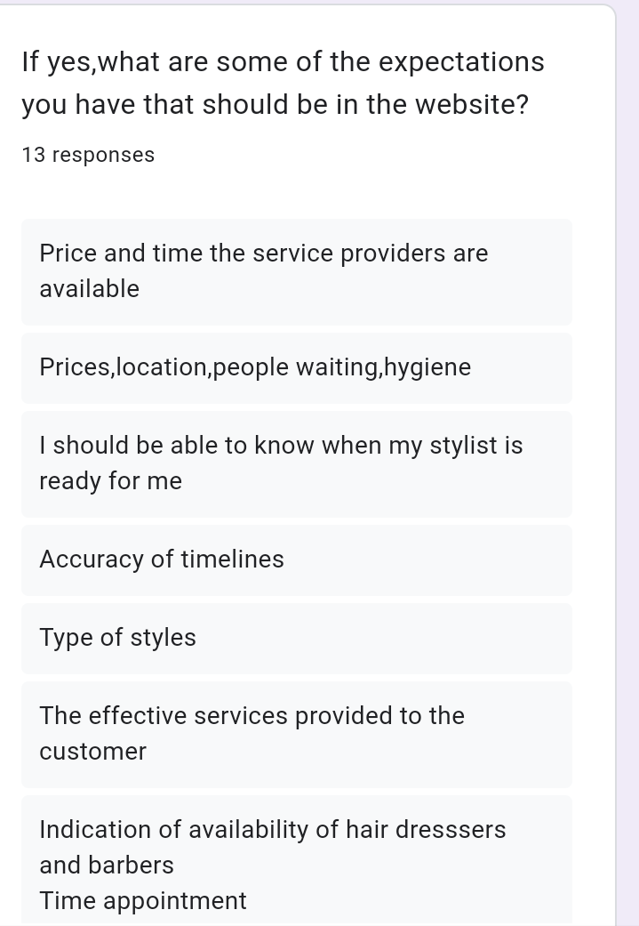

Figure 6. The questions asked in the survey

Most clients would like an updated system.

## **3.6.3 Interviews**

We visited the nearest salons, barbershops and beauty parlour and interviewed both the clients and service providers we found in the shops;

Most clients complained that they do not like the way the service providers are changed even if they have already started attending to them.

Most clients also complained of waiting too long for them to be attended to.

They complain of some customers booking early but arriving late when the service provider is already occupied with something else which may result to a conflict.

## **3.7 METHOD VALIDATION**

Interview was the most reliable data collection method during our data collection process since we got most challenges both the customers and service providers are facing.

## 3.8.DATA ANALYSIS TECHNIQUES

Table 1. Responses analysis based on gender

30% of the male population responded to our questionnaire and 45% of the female population responded.

# 

**CHAPTER 4: SYSTEM ANALYSIS AND DESIGN**

## **4.1 INTRODUCTION**

The booking system that we intended to design should be able to help mostly the client and customer and the beautician to have an easy time. The customer should be able to book appointment smoothly with the beautician and the beautician should also be able to know the customer they will attend to. The system should be based online to enable all that use smartphones and laptops to get access to it.

## **4.2 REQIUREMENT ANALYSIS**

Our hair and beauty booking system should always be reliable and easy to handle. It should always include non- functional & functional requirements.

### **4.2.1 Functional requirements**

The system must be able to allow the customers to display their feedback & give their opinions after the services.

It must be able to tell the clients the charges for the services they need

The system must be able to solve the problem of congestion in the organisation since it will let the client know when the beautician is not busy.

The system must be able to inform the client the beautician will attend to him /her and the probability of the time it will take to deliver the services required.

It must be able to inform the customer the available products in the system that will be used on them.

### **4.2.2 Non – functional requirements**

The system should be able to tell the client at what time the shop is closed or opened.

The system should inform the customer their other activities like dinner together to motivate them.

The system should be able to tell the customer the options of payment either credit card or cash.

## 4.3 SYSTEM ANALYSIS

### 4.3.1 USE CASE DIAGRAM

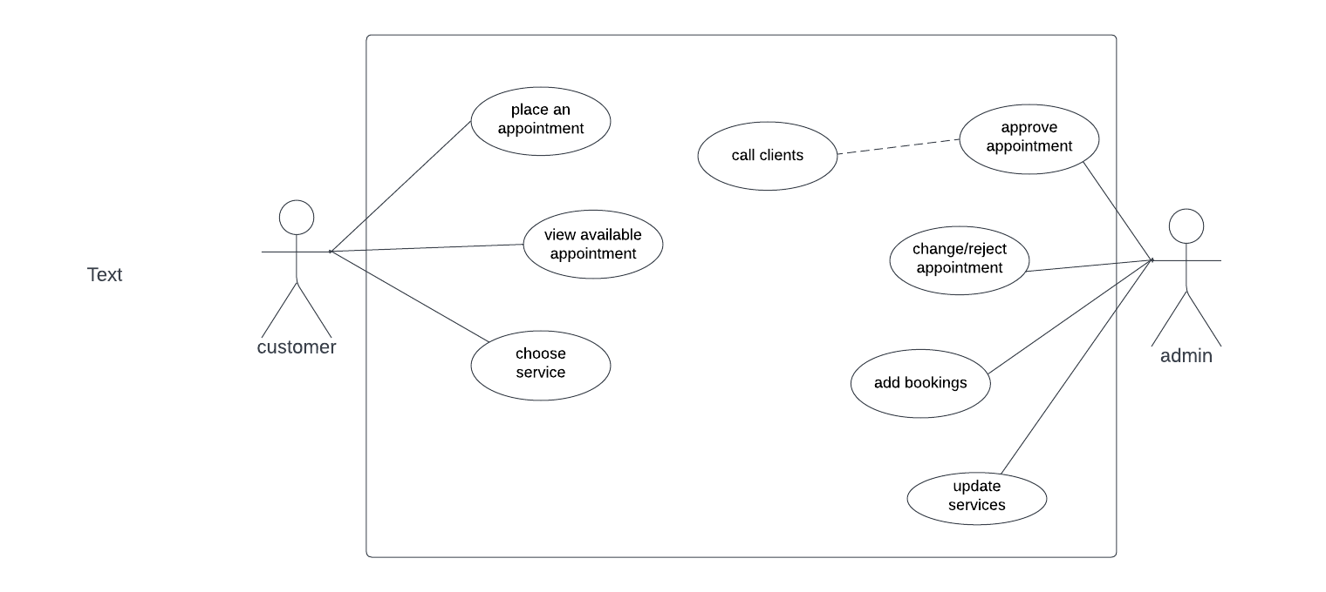

Figure 7. Use case

The above use case diagram is used to show the interaction of the customer and administrator with the system. In the system there are two actors who are, the administrator and the customer. The customer is able to view the appropriate time and date for themselves and be able to make an appointment. The administrator would be able to approve, reject or reschedule the client. The system allows the admin to send a notification message to the client.

### **4.3.2 DATA FLOW DIAGRAM**

Figure 8. Data Flow Diagram.

An illustration given by a data flow diagram. To give more insight of the project.

## **4.4 SYSTEM DESIGN**

### 4.4.1 ACTIVITY DIAGRAM

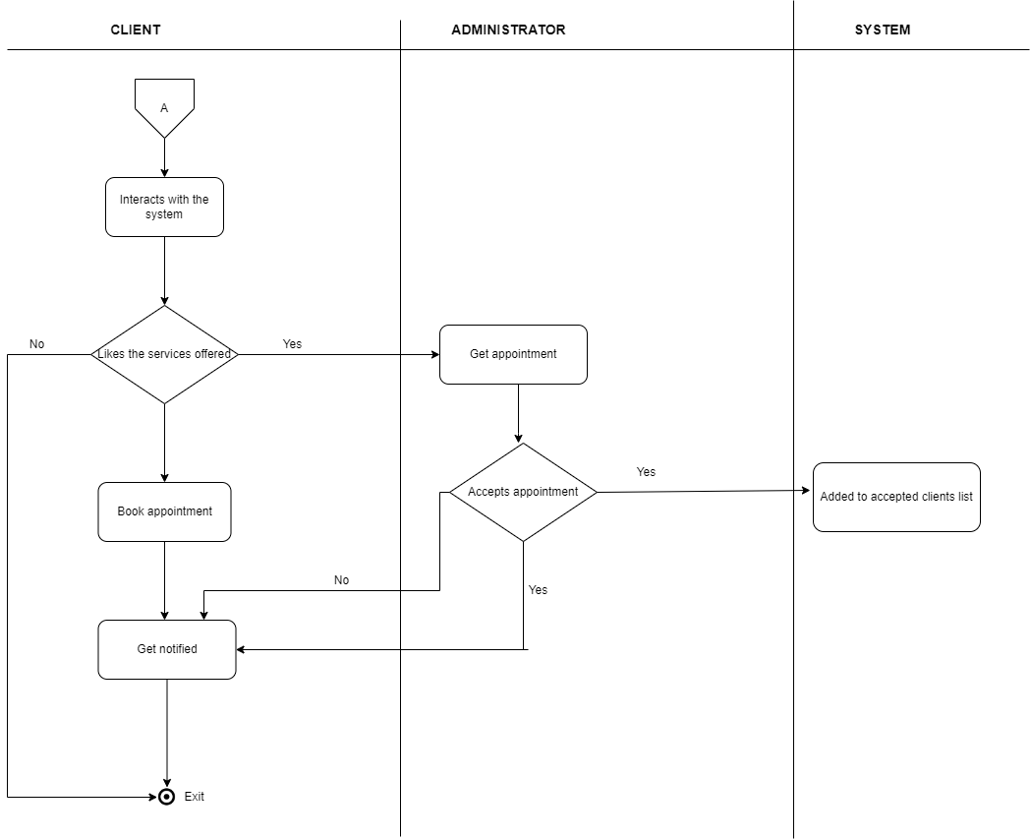

Figure 9.Activity diagram

Activity diagram giving an illustration of how a client interacts with the system and the administrator would be able to receive and reject appointments.

## **4.4.2 SEQUENCE DIAGRAM**

### a). Client Sequence Diagram

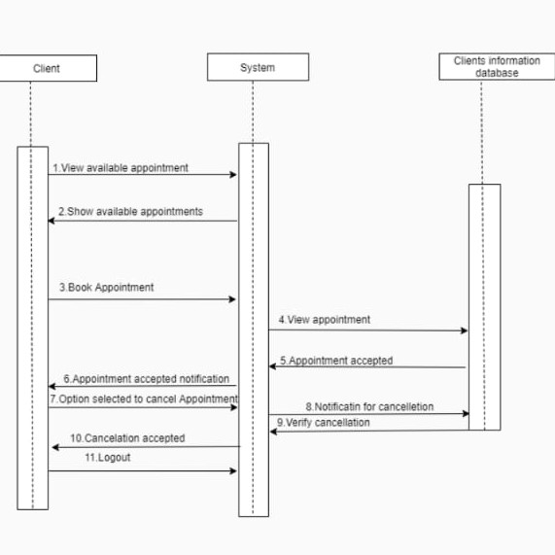

Figure 10.A Client sequence diagram

The above sequence diagram gives an illustration of how the client gets to interact with the system. A client will be able to view the dates that they would want to be attended to. The sequence diagram gives an illustration of how the information will flow from the client to the system where it is stored and made available to the administrator.

### b). Administrator sequence diagram

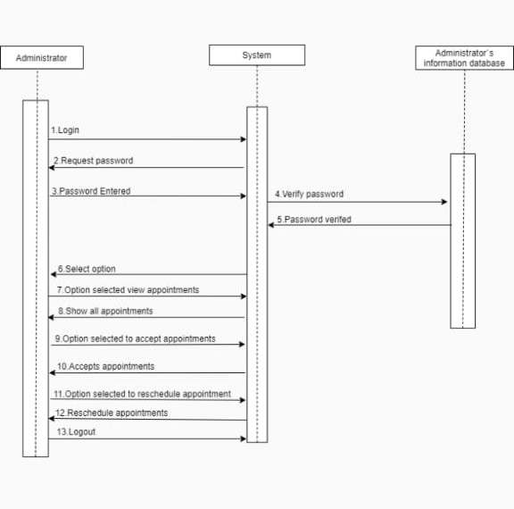

Figure 11. Administrator sequence diagram

The administrator sequence diagram gives an illustration of how the administrator gets information from the system and be able to make the necessary/ appropriate decision.

## 4.4.3 CLASS DIAGRAM

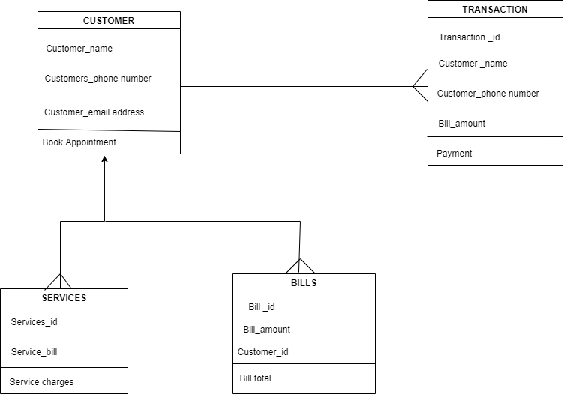

Figure 12.Class diagram

The class diagram illustrates that,one customer can access many services.

One customer can be responsible for many bills.

One customer can make many transactions.

### 4.4.4 ADMINISTRATOR INTERFACE

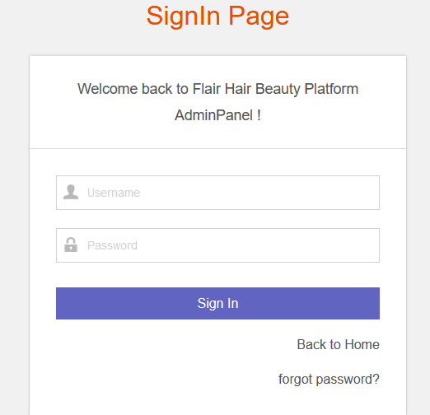

Figure 13.Administrator interface

An interface that allows the administrator to log in.

### 4.4.4 APPOINTMENT INTERFACE

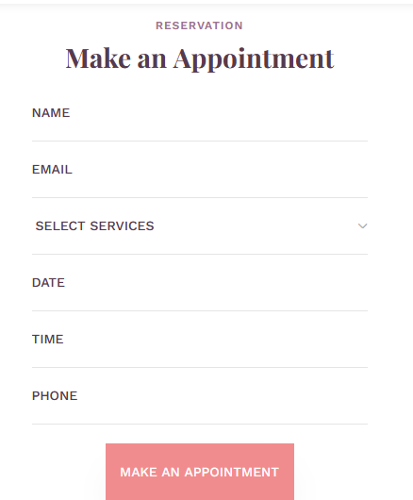

Figure 14. A booking interface

An interface that allows a client to book beautician appointment.

# 

### 4.4.5 DEPLOYMENT DIAGRAM

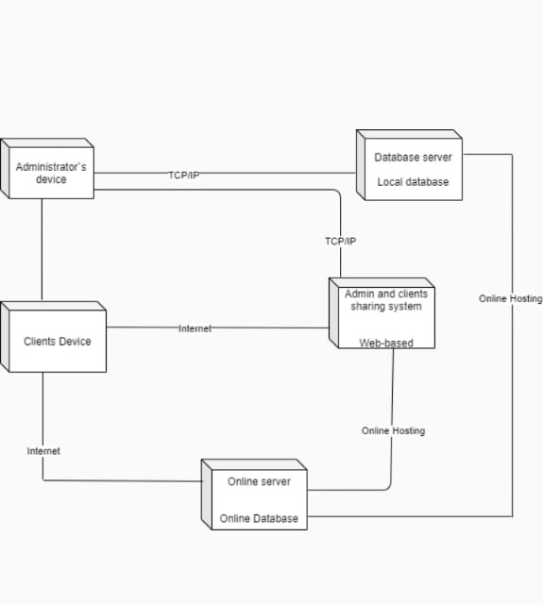

Figure 15.Deployment diagram

A deployment diagram that shows how information flows amongst the administrator device, the database server, clients device and the online database.

# **CHAPTER 5: TESTING AND IMPLEMANTATION**

## **5.1 INTRODUCTION**

The testing and implementation of the system focuses on the management of data and data transfer from current system to the new system. Different methods are to be used in testing the system and implementation it. Training of individuals concerned is also required so as to enable sufficient efficient transfer of the required information.

5.2 TESTING OBJECTIVES

i. To verify the fulfilment of all specified requirements.

ii. To validate if the test object is complete and works as per the expectation of the user and stakeholders.

iii. To find and prevent defects in the software products.

iv. To build confidence in the software products.

v. To evaluate the requirements.

## **5.3 METHODS USED IN TESTING**

The method used in testing were component testing and system testing. Under component testing, we used it to test object such as components, code and data structures, classes

and database modules. This helped in ensuring the shared components will not be broken and also minimized data security threats to the system and also ensured data was being saved in the database correctly.

Under system testing, we tested the whole system in entirely, this includes all modules all modules integrated .To verify if the system work as expected or not. The help in evaluating the behaviour of the system based on predetermined specification and requirements.

### **5.3.1 Test data plans**

We divided testing procedure into two levels; component testing and system.

Unit testing is set to test the internal logic of the modules.

Testing of flair hair and beauty management system. In case of flair hair and beauty management package, I perform unit testing to each individual function to see that whether they were working properly or not. We examined each loop, which occurred in the function in

each possible value. Integration testing was being performed by combining the different modules and the results were examined. So the steps are taken for testing:

1. Proper validation is done or not
2. Expectations are handled or not.
3. Correct menus are opened or not.
4. Records are properly updated and saved or no.

### 5.3.1.1 Login authentication:



Figure 16. Login authentication

The customer will be required to fil in his/ her details in order to book their appointments.

### 5.3.1.2 Additional of services.

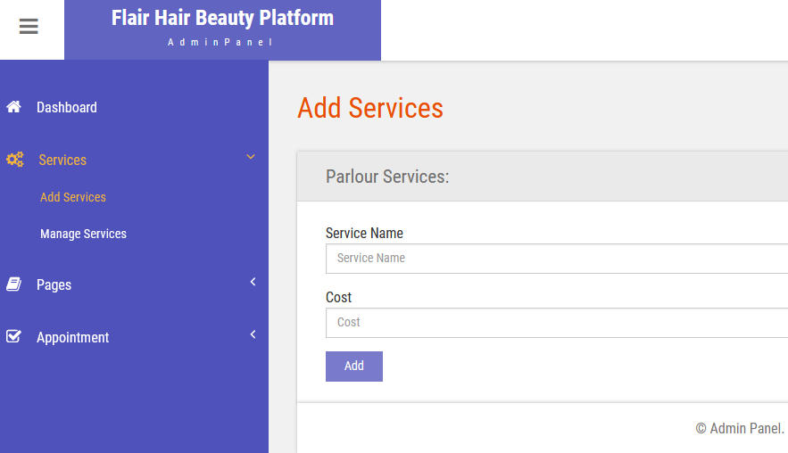

Figure 17.A picture of how an admin can add or remove services

## **5.4 IMPLEMENTATION**

## 5.4.1 Definition

Implementation refers to the process of adopting and integrating a software application into a business workflow. It can be difficult to implement new software in the beauty parlour since

it depends on the size of the organisation and the software. Implementation takes an

extraordinary amount of time and a large amount of coordination.

### 5.4.2 File conversion strategy

The new system is implemented and an old system is replaced. It forces users to make a new

system work and immediate benefits from the new methods and control. It requires the

automated methods, testing and parallel operations, continuous support for correcting problems etc.

### **5.4.3 Implementation method**

Direct implementation

This method of implementation the users stop using the old system and start using the new one. It has its own advantages such as it is less costly and saves time than any other method of implantation.

### **5.4.4 Acquisition of hardware and software**

The software developed is suitable for any hardware. For our case Flair hair and beauty website can be used together with any hardware since it is a web-based software.

### **5.4.5 Training the user**

Before the usage of the system, the key users of the system must be trained by people who really understand the system. This helps to create an atmosphere of interest and acceptance. Training involves creating troubleshooting lists to identify possible problems and solutions for them. It also involves being familiar with run procedures which involves working through the sequence of activities needed to use a new system.

**5.4.6 Installation and implementation**

The implementation phase of the project has by far been the most challenging of the phases of this project. Because of the significant time constraint, many functions that initially seemed trivial to implement became very time consuming to implement. There might be a few errors here and there, not because we weren`t keen while doing the project but simply because the code was quite complex. There might be software bugs on the code. I guess like humans; computers are to error. We implemented our project by first drawing our project`s interface using Figma. We chose an interface that would be easier to interact.

For the coding, we used visual studio because it is the software application that would be reliable for using HTML, CSS, JavaScript and PHP files.

# **CHAPTER 6: SYSTEM DOCUMENTATION**

# **6.1 INTRODUCTION**

In this chapter, one will be able to access the group`s strategy that we used,our progress, metrics and the achieved results. This is so as to provide complex vision of our project, and offer many practical benefits.It will also help to analyze the efficiency of the testing,remove the uncertainities of any testing activities and also to help set up the testing environment.

**6.2 TYPES OF SOFTWARE DOCUMENTATION**

Software documentation is the information that describes the project to the people who develop and use it.

### a). Internal software documentation.

It is majorly used inside of a company or the targeted area of implementation.

* Administrative documentation

It is the high level administrative guideline.These are majorly those who are in a higher hierachy .

* Developer documentation

This provides instructions to developers for building the software and guides them through the development process.It includes requirements documentation, which describes how the software should perform when tested. It also includes architectural documentation that focuses on how all the components and features work together, and details data flows throughout the product.

### b). External software documentation

It is created with an aim to provide IT managers and end users with information on how to deploy and use the software.

* End - user documentation

This type gives end users basic instructions on how to use, install and troubleshoot the software.It might provide resources, such as user guides, knowledge bases, tutorials and release notes.

* Enterprise user documentation

Enterprise software often has documentation for IT staff who deploy the software across the enterprise.It may also provide documentation for the end users of the software.

* Just -in- time documentation

This provides end- users with support documentation at the exact time they will need it.This allows developers to create a minimal amount of this .

## 6.3 TECHNICAL DOCUMENTATION

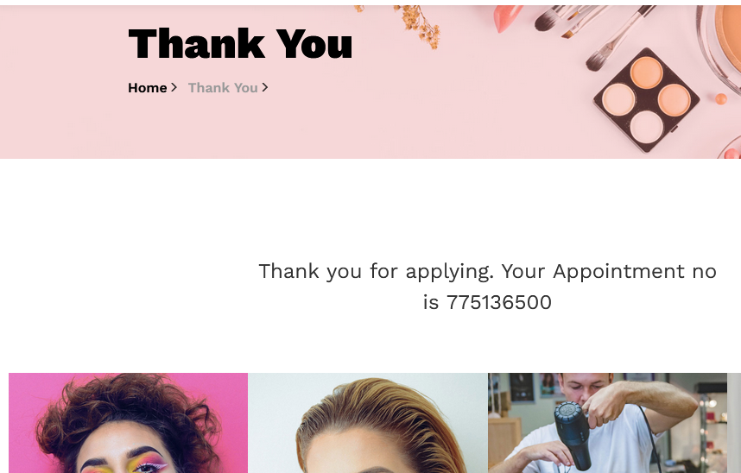

Figure 18. Picture notifying that the booking was successful.

This verifies that the booking interface performs correctly. We achieved our objective of making it easier for a client to book an appointment.

b). Admin login interface

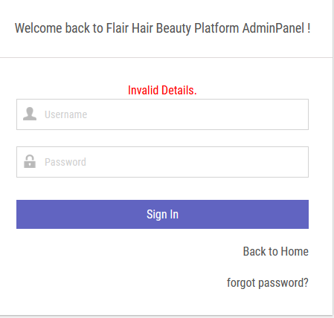

Figure 19. A picture showing that admin interface woks correctly.

The above image gives the clarification that the admin interface is fully functioning,

such that it does store information. Whenever it`s not correct it gives you information.

Test procedure – Enter the admin username then type in the password then click on the sign in button.

Test data – Admin username and password.

Expected result – Admin should login successfully on entering the correct password.

Actual result – If the admin details are correct them it proceeds to the admin dashboard. If the password

is incorrect, it doesn`t open. It gives a notification to them, gives them an option to go back to the home

page or to choose if they forgot the password.

Status – Logging in to the admin dashboard.

**6.4 USER MANUAL**

1. Open the Xampp software and start the apache and MYSQL modules.

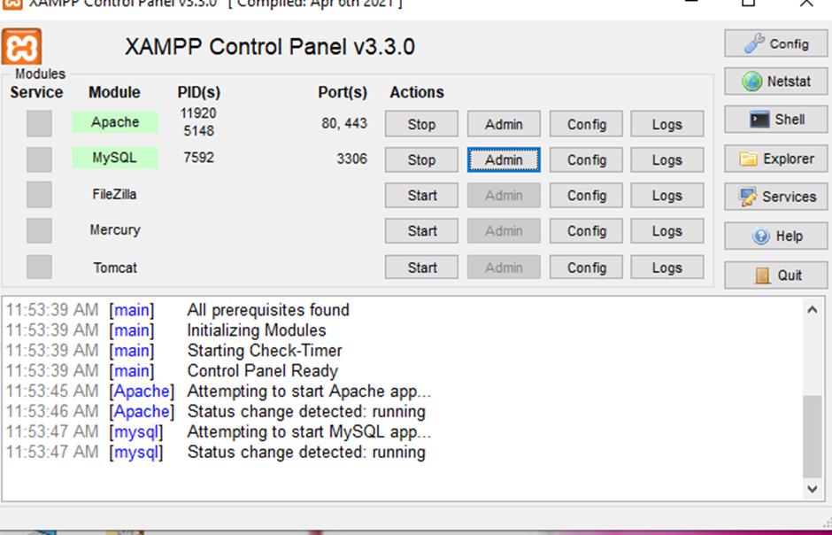

Figure 20. How to start xampp

2. To feed data to your system , go to your local browser and search for phpMyAdmin .

3.Fill in the desired informaion and save it.

4. Ensure to connect the php files with the html and css files.

5.Copy the file path and go back to your browser.

6. Paste it in followed by the copied file path. Then let the browser do its work.

# *REFERENCES*

*Abel’s on Queen Barbershop*. Retrieved May 26, 2022

*Home | Fringe Hair Salon*. Retrieved May 26, 2022,

*TONI&GUY UK*. Retrieved May 26, 2022

*Lisa Dinh Hair Studio*. Retrieved May 26, 2022, from http://lisadinhhairstudio.com/

*Nine Zero One – Located in the heart of Los Angeles, on Melrose Place. Nine Zero One is the home away from home for every client who walks in the door. The salon prides itself on creating the ultimate you in a contemporary, inspired atmosphere unlike any other.*

Retrieved May 26, 2022

*Salon Management & Scheduling | Phorest Salon Software | Ireland*. Retrieved May 26, 2022

*Best Natural Hair Salon in Nairobi (CBD) Kenya | Divas Beauty Spot*. Retrieved May 26, 2022

*flair beauty studio - Search*. Retrieved May 26, 2022

*HOME | Platinum Beauty Bar*. Retrieved May 26, 2022

*bionic beauty salon - Search*. Retrieved May 26, 2022

# APPENDIX

**Section A: Download and Install XAMPP.**

**What is XAMPP?**

XAMPP is the most popular PHP development environment, XAMPP is a completely free, open-source and easy to install Apache distribution containing MariaDB and Perl.

**How do I download it and from where?**

You can download it from the XAMPP download page, you can get the stable version there.

**How to install and where to place my PHP/html files?**

**Install with the provided installer**

1.Execute the XAMPP server installer by double clicking the download .exe.

**Install from the ZIP**

1.Unzip the zip archives into the folder of your choice.

2.XAMPP is extracting to the subdirectory c:\ xampp below the selected target directory.

**Post- install**

Use the “XAMMP Control Panel” for additional tasks, like staring or stopping Apache, MySQL, FileZilla and Mercury or installing these as services.

**File handling**

The installation is a straight forward process and once the installation is complete you may add html/php files to be hosted on the server in XAMPP-rot/ ht docs/. Then start the server and open http:// localhost/file.php on a browser to view the page.

**SECTION B: Download and install Visual Studio**

**What is visual studio?**

It is a source – code editor made by Microsoft for Windows, Linus and macOS.

**How do I download it and from where?**

Download the visual studio bootstrapped file by selecting the download button and saving it to the downloads folder.

**Install the visual studio installer.**

1.From your downloads folder, double-click that matches, vs_ community.exe ,vs_ proffesional.exe or vs_ enterprise .exe .

2.It will ask you to acknowledge the Microsoft License Terms and the Privacy Statement.

3. Choose to continue.

**Choose workloads**

1.Choose all the workloads that you want in the visual studio, for example ASP.NET and web development.

2.Select install

**Choose individual components**

Choose what you want and then follow the prompts

**Select the installation location.**

Reduce the installation footprint of Visual Studio on your system drive.

**Start developing**

1.After installation is complete, select the launch button to get started.

2.On the windows page choose **Create new project**

**Note; You can also filter your search for a specific language by using the dropdown list**

3.Visual studio opens your new project and your new project is ready to be coded!

**GANTT CHART**

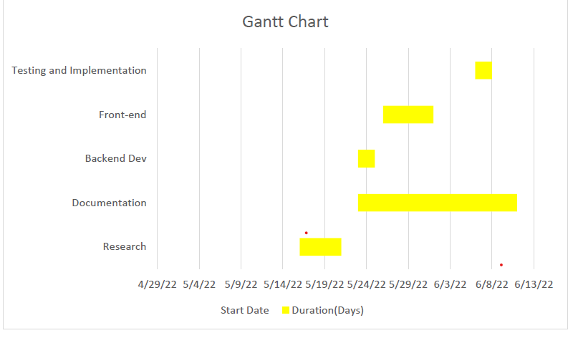

*Figure 21. gantt chart*

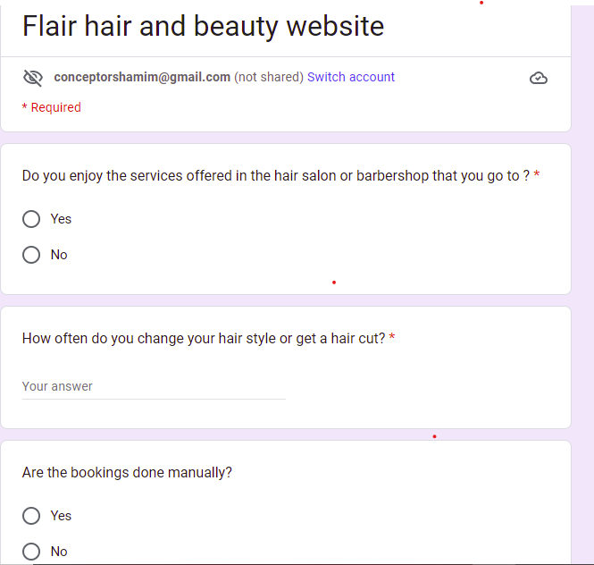

Figure 21 Google forms1

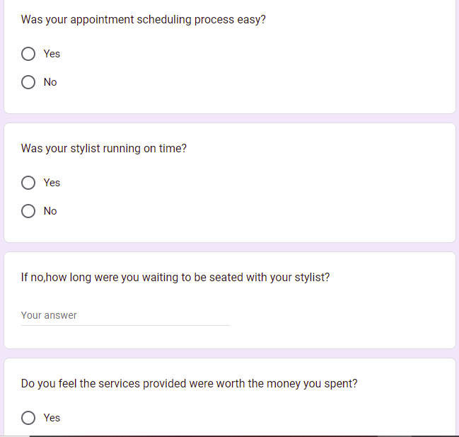

Figure 22 Google forms 2

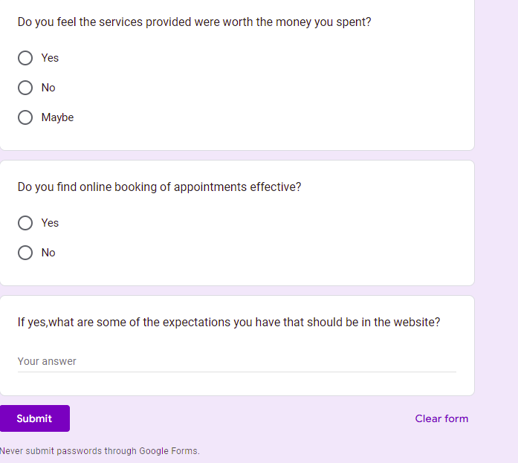

Figure 23 Google forms 3